|  |
| --- |
|  |
| **一、登录学信网，点击学信档案 （手机端和 pc 端流程一致）**   |  | | --- | |  |   **→查看本人学籍信息**   |  | | --- | |  | |

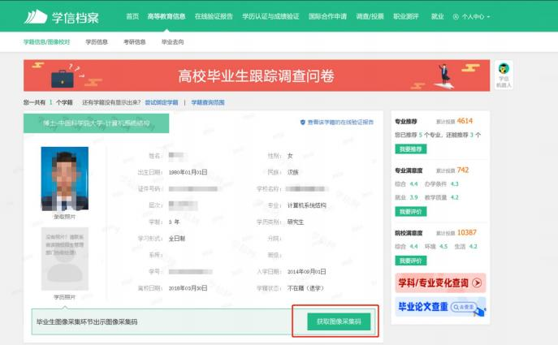

|  |
| --- |
|  |

|  |
| --- |
| **→选择学籍，查看对应采集码并保存图片** |

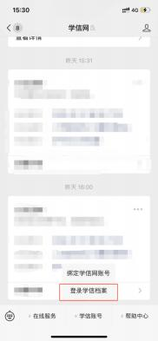

|  |
| --- |
|  |

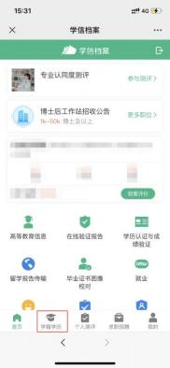

|  |
| --- |
|  |

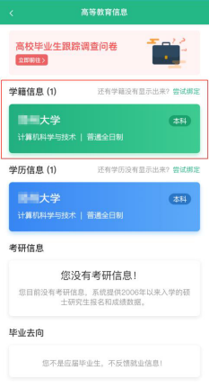

|  |
| --- |
|  |

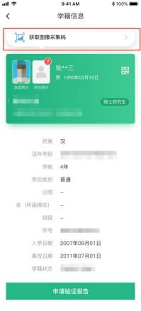

|  |
| --- |
|  |

|  |
| --- |
| **二、“学信网”微信公众号**  1.关注学信网公众号，绑定学信网账号，点击“学信账号”，查看学籍学历信息  2.选择学籍，查看对应采集码 |

|  |  |  |  |  |
| --- | --- | --- | --- | --- |
| |  | | --- | |  |  |  | | --- | |  |   **三、学信网 APP**  1.登录学信网 APP，点击“学籍查询”，查看学籍学历信息   |  | | --- | |  |   2.选择学籍，查看对应采集码   |  | | --- | |  | |